Project Title: Knowledge Graph for E-commerce Customer Behaviour and Financial Analysis
Name: Aman Bhardwaj
Mode: ☐ 6 ECTS / ☒ 3 ECTS
Representations
(LO1) Understand and apply  Knowledge Graph Embeddings | ☒ I showed basic proficiency  ☐ exceeded basic proficiency
I applied Node2Vec to learn 64-dimensional vector representations of entities in the Knowledge Graph. I evaluated the resulting embeddings using a project-defined structural similarity evaluation based on graph connectivity and nearest-neighbour relationships. | Section 3, especially Sections 3.1–3.3.

(LO2) Understand and apply  logical knowledge in KGs | ☐ I showed basic proficiency  ☒ exceeded basic proficiency
I implemented four logical forward-chaining rules to derive new customer-product, customer-category, customer-seller, and order-sentiment relationships. The reasoning process uses indexed graph traversal, multiple iterations, and stops at a fixed point when no further facts can be derived. | Section 4, especially Sections 4.1–4.4.

(LO3) Understand and apply  Graph Neural Networks | ☐ I showed basic proficiency  ☐ exceeded basic proficiency
Not covered in this project. The project uses Node2Vec for graph embeddings, but does not implement or evaluate a Graph Neural Network. | Not covered.

(LO4) Compare different Knowledge Graph data models from the database, semantic web, machine learning and data science communities. | ☒ I showed basic proficiency  ☐ exceeded basic proficiency
I compared relational databases, RDF/Semantic Web representations, property graphs, and document databases with respect to representation, relationships, schema flexibility, querying, and graph traversal. I then justified the use of a property graph for this project and discussed its connection to Node2Vec-based graph representation learning. | Section 5.2.
Systems
(LO5) Design and implement architectures  of a Knowledge Graph | ☒ I showed basic proficiency  ☐ exceeded basic proficiency
I designed and implemented a layered Knowledge Graph architecture covering data loading and integration, graph construction, enrichment, logical reasoning, graph embeddings, analytics, and service presentation. The resulting graph integrates customers, orders, products, categories, sellers, payments, reviews, sentiment, and geographic information. | Section 2, especially Sections 2.2–2.3.

(LO6) Describe and apply scalable reasoning methods in Knowledge Graphs | ☒ I showed basic proficiency  ☐ exceeded basic proficiency
I implemented indexed forward chaining rather than using unrestricted graph joins, allowing the four reasoning rules to be applied efficiently over the large graph. The reasoning process reached a fixed point after three iterations and added 362,830 inferred relationships; scalability is nevertheless limited by the in-memory NetworkX representation. | Section 4, especially Sections 4.2–4.5.

(LO7) Apply a system to create  a Knowledge Graph | ☐ I showed basic proficiency  ☒ exceeded basic proficiency
I implemented an end-to-end pipeline that integrates the Olist datasets and creates a multi-layer Knowledge Graph with 442,401 nodes and 1,085,835 relationships after enrichment and reasoning. The pipeline also validates the graph structure and exports the resulting KG for downstream analysis and services. | Section 2, especially Sections 2.1–2.3.

(LO8) Apply a system to evolve  a Knowledge Graph | ☒ I showed basic proficiency  ☐ exceeded basic proficiency
I evolved the initial Knowledge Graph through additional sentiment, geographic, and logical enrichment. In particular, TextBlob-based sentiment information and geographic clusters are added as new knowledge, while logical forward chaining derives additional relationships. | Sections 2.3 and 4.3–4.4.

Applications
(LO9) Describe and design real-world applications of Knowledge Graphs | ☐ I showed basic proficiency  ☒ exceeded basic proficiency
I designed a real-world e-commerce Knowledge Graph application for analysing customer behaviour, products, categories, sellers, reviews, transactions, and geographic relationships. The KG supports analytical queries, customer and product analysis, sentiment analysis, graph exploration, and interactive services through a Streamlit application. | Section 1 and Section 2, especially Sections 2.2–2.3.

(LO10) Describe financial Knowledge Graph applications | ☒ I showed basic proficiency  ☐ exceeded basic proficiency
I extended the e-commerce KG with financial analysis of payments, customer spending, order values, repeat purchasing, and seller sales. The project demonstrates how financial information can be connected to customer, order, product, and seller entities in a Knowledge Graph, while keeping the analysis descriptive rather than presenting it as a formal financial or predictive model. | Section 1 and Section 2.3, with financial results discussed in Section 5.

(LO11) Apply a system to provide services through a Knowledge Graph | ☐ I showed basic proficiency  ☒ exceeded basic proficiency
I implemented a Streamlit-based Knowledge Graph service that provides natural-language-style analytical queries, graph exploration, entity search, analytics, and graph metrics. The query interface uses deterministic intent detection and graph traversal to answer questions directly from the Knowledge Graph. | Section 1 and Section 5.1.

(LO12) Describe the connections between Knowledge Graphs (KGs), Machine Learning (ML) and Artificial Intelligence (AI) | ☒ I showed basic proficiency  ☐ exceeded basic proficiency
I connected Knowledge Graphs with several AI/ML techniques: Node2Vec provides graph-based representations, TextBlob provides sentiment enrichment, logical reasoning derives new knowledge, and analytical services use the resulting KG structure. The project therefore demonstrates how symbolic graph knowledge and data-driven methods can complement each other. | Section 5.3.
Additional Information
HAS NO EFFECT ON MARKING!
(please fill it out honestly, even if it is less than what is suggested in the ECTS breakdown – you are not judged on time spent!)

How many hours did you spend on your  mini-project? | 50 hours
* please exclude any hours you spent on parts reused from other courses

How many hours did you spend on your  portfolio document preparation (this PDF)? | 15 hours
* please exclude any hours you spent on parts reused from other courses
Declaration
I have marked all parts generated by Generative AI (e.g., ChatGPT) or otherwise copied from other sources and given any prompt I used either in a footnote or in an appendix making clear which parts are generated by which prompts or similar. | ☒ I confirm this

Please indicate if you have used generative AI parts of the mini-project | ☐ I used it for roughly  <XX>% of the mini-project
<If this is the case, please describe here what parts you generated and what you did yourself to fulfil your learning outcomes.>

Please indicate if you have used generative AI parts of this document | ☐ I used it for roughly  <XX>% of this document
<If this is the case, please describe here what parts you generated and what you did yourself to fulfil your learning outcomes.>

Portfolio Report
Knowledge Graph for E-commerce Customer Behaviour and Financial Analysis
1. Introduction
This project develops a Knowledge Graph (KG) for analysing customer behaviour and financial activity in an e-commerce environment using the Brazilian Olist e-commerce dataset. The main goal is to integrate customers, orders, products, categories, sellers, payments, reviews and geographical information into one connected graph that supports analytical queries, logical reasoning and graph-based machine learning.
The project focuses primarily on creating and applying a Knowledge Graph (LO7) and demonstrating a real-world KG application (LO9). Additional work covers Knowledge Graph embeddings (LO1), logical reasoning (LO2), KG data-model comparison (LO4), KG architecture (LO5), reasoning methods (LO6), KG enrichment (LO8), financial KG applications (LO10), KG-based services (LO11), and the relationship between KGs and machine learning (LO12). Graph Neural Networks (LO3) were outside the project scope.
The final pipeline completed successfully and produced a KG containing 442,401 nodes and 1,085,835 relationships, including 362,830 inferred relationships.
2. Background and Dataset
E-commerce data contains many interconnected entities. A customer places an order, an order contains products, products belong to categories and are offered by sellers, while orders are connected to payments and reviews. These relationships are difficult to explore through isolated tables, especially when several relationships have to be followed simultaneously.
A Knowledge Graph provides a natural representation for this type of problem because entities and their relationships can be explicitly represented and traversed. The project therefore uses a property-graph-style representation with NetworkX. The Olist dataset consists of several related CSV files. After validation and cleaning, the main datasets contained:
Dataset | Records
Customers | 99,441
Orders | 99,441
Order items | 112,650
Products | 32,951
Payments | 103,886
Sellers | 3,095
Reviews | 99,224
Geolocation | 738,332
Categories | 71
The data-loading stage performs schema validation, duplicate checking, missing-value inspection, type conversion and category translation. Duplicate geolocation records were removed before graph construction.
3. Method
3.1 Knowledge Graph construction (LO7)
The core of the project is the construction of a property graph (LO7). The graph represents entities such as customers, orders, products, categories, sellers, payments, reviews, cities and states.
Important relationships include:
- Customer -[PLACED]-> Order
- Order -[CONTAINS]-> Product
- Product -[BELONGS_TO]-> Category
- Product -[OFFERED_BY]-> Seller
- Order -[HAS_PAYMENT]-> Payment
- Order -[HAS_REVIEW]-> Review
- Review -[HAS_SENTIMENT]-> Sentiment
The initial graph contained 442,390 nodes and 677,982 explicit relationships. Later enrichment added additional entities and relationships.
The final KG contained:
- 442,401 nodes
- 1,085,835 relationships
- 723,005 explicit relationships
- 362,830 inferred relationships
The graph was structurally validated. All nodes had a node-type and all edges had a relationship type. The final graph consisted of one connected component. Below is a visualization of the KG with Depth = 2 and nodes =
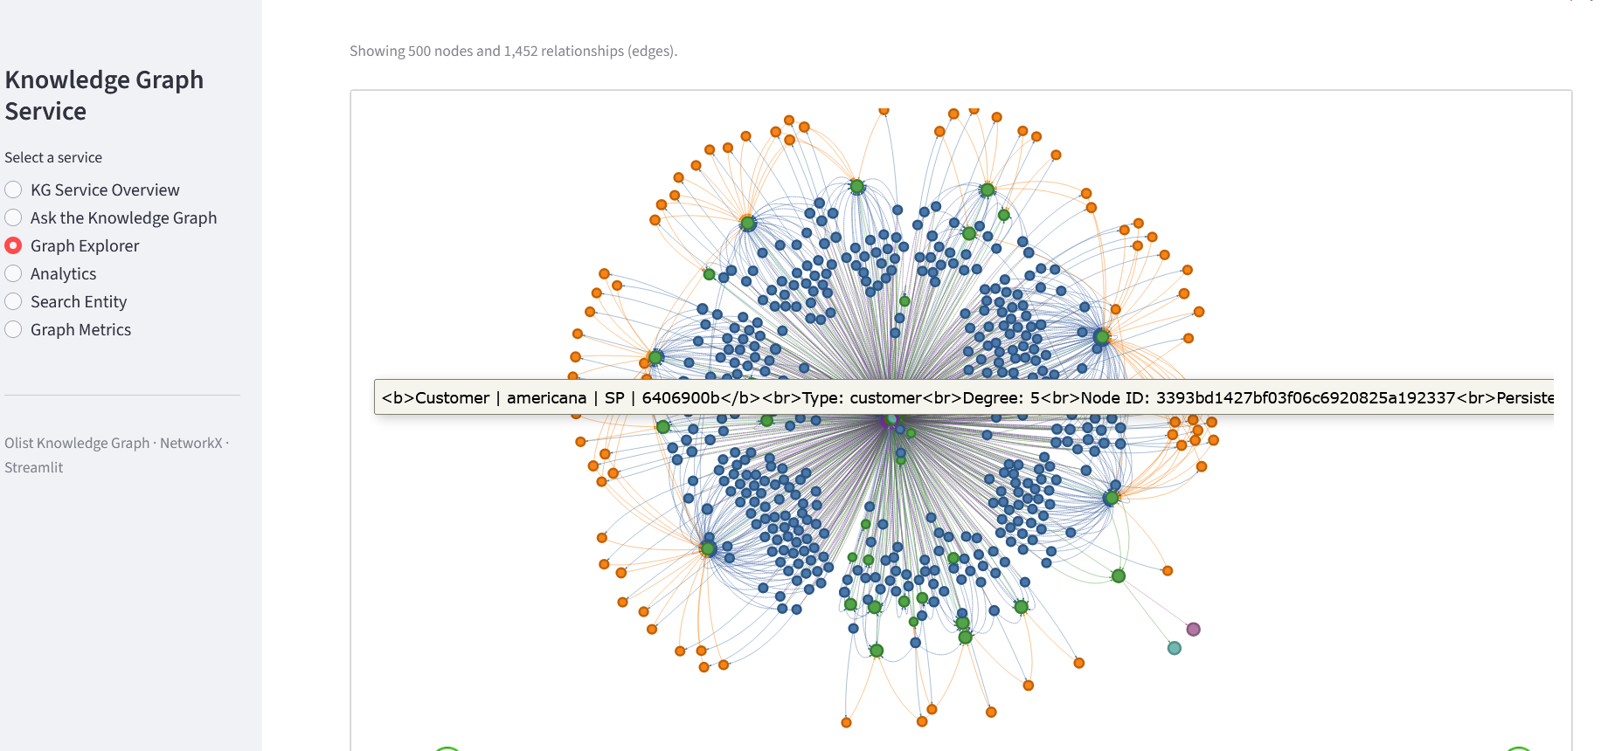
3.2 Data-model choice (LO4)
The project compares relational databases, RDF/Semantic Web, property graphs and document databases (LO4).
The relational model is useful for the original Olist tables, while RDF provides strong semantic interoperability and ontology-based modelling. Document databases are flexible for document-oriented information. The property graph was selected because the project requires direct multi-hop traversal, relationship-oriented analysis and graph-based representation learning.
The chosen graph structure is also used as input to Node2Vec, connecting the data-model decision to the later machine-learning stage.
3.3 Analytical and financial layer (LO9, LO10)
The KG supports customer and business analysis by connecting transaction information with customers, products, categories and sellers.
The final analysis produced:
Measure | Result
Total payment value | 16,008,872.12
Average order value | 160.99
Orders | 99,441
Persistent customers | 96,096
Repeat customers | 2,997
Products | 32,951
Categories | 71
Sellers | 3,095
Payments | 103,886
Reviews | 99,224
For example, 2,997 persistent customers were identified as repeat customers because they were associated with more than one order.
The project also implements a financial KG application (LO10). Payment entities are connected to orders, which indirectly connects financial activity with customers, products, categories and sellers. Customer financial profiles were generated using total payment value, order activity and product/category relationships.
3.4 Knowledge Graph enrichment (LO8)
The KG is extended with derived information, demonstrating KG enrichment and evolution (LO8).
Sentiment enrichment
Review text was analysed using TextBlob. 40,950 review texts were processed.
The TextBlob results were:
Sentiment | Count
Neutral | 37,468
Positive | 3,034
Negative | 448
The average TextBlob polarity was 0.0272. The NLP layer adds sentiment properties and HAS_NLP_SENTIMENT relationships while preserving the original review-score sentiment separately. This means the graph can distinguish between sentiment derived from a structured review score and sentiment derived from review text.
Geographic enrichment
The project also analysed 738,332 geographical points and created 8 derived geographic clusters with 4,073 city-cluster relationships.
These clusters are represented in the KG as derived analytical entities and can support regional demand, customer distribution and logistics-oriented analysis.
3.5 Logical reasoning (LO2, LO6)
A central KG component is rule-based logical inference (LO2).
Four rules were implemented. They infer:
- Customer → Product interaction from Customer → Order → Product.
- Customer → Category association from Customer → Product → Category.
- Customer → Seller association from Customer → Product → Seller.
- Order → inferred NLP sentiment from Order → Review → NLP Sentiment.
The reasoning engine uses indexed forward chaining and continues until no new facts can be derived (LO6). The results were:
Reasoning measure | Result
Explicit relationships before reasoning | 723,005
New inferred relationships | 362,830
Final relationships | 1,085,835
Expansion ratio | 1.50×
Relationship increase | 50.18%
Reasoning time | 15.07 seconds
The process reached a fixed point after three iterations. The third iteration generated no new facts.
This demonstrates how information that is implicit in several graph paths can be converted into explicit inferred knowledge.
3.6 KG embeddings (LO1, LO12)
The final graph was used for graph representation learning with Node2Vec (LO1).
The configuration used:
- 64-dimensional embeddings
- Walk length: 20
- 30 walks per node
- Context window: 10
- p = 1.0
- q = 1.0
Node2Vec represents nodes as numerical vectors based on their graph neighbourhoods. Similar graph contexts can therefore produce similar vector representations.
For example, the translated/original category representations showed high similarity:
- cama_mesa_banho ↔ bed_bath_table: 0.9808
- beleza_saude ↔ health_beauty: 0.9843
A project-defined structural evaluation using a three-hop criterion produced:
- True positives: 45
- False positives: 5
- Structural precision: 0.90
- Embedding diversity score: 0.7113
Node2Vec graph embedding technique demonstrates a direct connection between KG structure and machine-learning representation learning (LO12).
3.7 KG-based service and application (LO9, LO11)
The project provides a deterministic Knowledge Graph query service and an interactive Streamlit application (LO11).
The query service supports questions involving:
- customers and orders
- products and categories
- sellers
- payments and average order value
- repeat customers
- customer spending
- sentiment
- customer-specific products, categories and sellers
The Streamlit application provides:
- KG overview
- graph exploration
- entity search
- general analytics
- individual entity analytics
- saved analytical results
The service is deterministic and uses graph traversal and predefined analytical intents rather than an external LLM. It therefore demonstrates how a KG can provide an analytical service directly to users (LO11). A screenshot of a query on KG is as under:
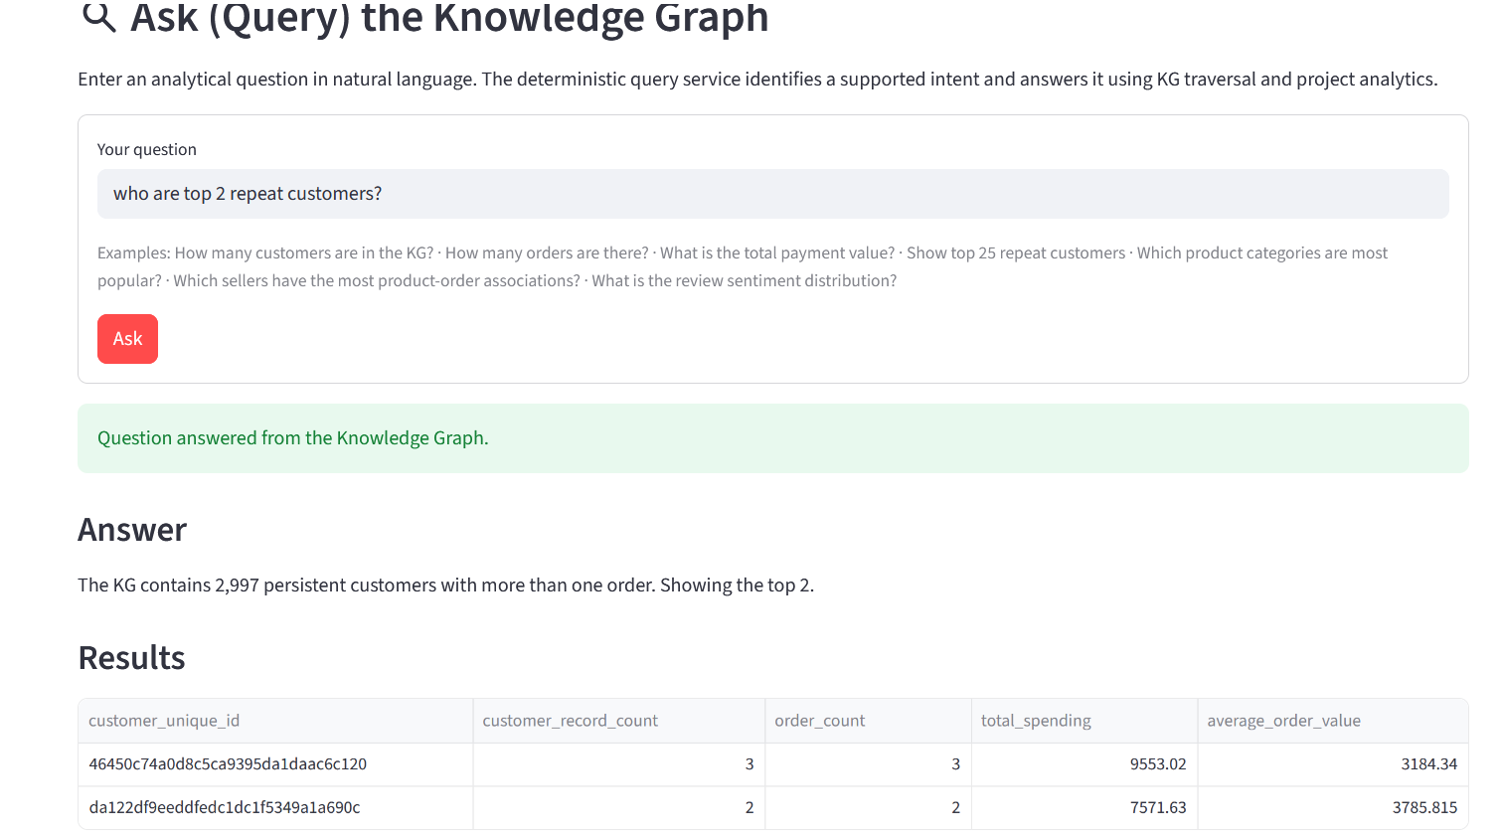
4. Results
The final pipeline successfully completed all major stages: data validation, graph construction, enrichment, reasoning, validation, Node2Vec embedding, query-service preparation, graph export and visualization.
The most important final results are:
Knowledge Graph
- 442,401 nodes
- 1,085,835 relationships
- 723,005 explicit relationships
- 362,830 inferred relationships
- 1 connected component
- Average degree: 4.91
Customer and financial analysis
- 96,096 persistent customers
- 2,997 repeat customers
- 16,008,872.12 total payment value
- 160.99 average order value
- 99,441 orders
KG enrichment
- 40,950 review texts analysed
- 8 geographic clusters
- 4,073 geographic relationships
- Separate structured and NLP sentiment representations
Reasoning
- 362,830 inferred facts
- 50.18% increase in relationships
- 15.07 seconds reasoning time
- Fixed point reached after three iterations
Embeddings
- 64-dimensional Node2Vec vectors
- 0.90 project-defined structural precision
- 0.7113 embedding diversity score
These results show that tgraph is enriched, queried, reasoned over and used as input for representation learning.
5. Learning Outcomes
The project provides evidence for the following learning outcomes:
LO | Evidence
LO1 | Node2Vec graph embeddings and similarity evaluation
LO2 | Four rule-based logical inference rules
LO3 | Not covered; GNNs were outside scope
LO4 | Comparison of relational, RDF, property-graph and document models
LO5 | Complete KG architecture and implementation
LO6 | Indexed forward chaining and fixed-point reasoning
LO7 | Construction of a 442,401-node KG
LO8 | Sentiment and geographic KG enrichment
LO9 | E-commerce customer, product, seller and behavioural application
LO10 | Payment-based financial KG analysis and customer financial profiles
LO11 | Query service and Streamlit KG application
LO12 | Connection between KG structure and machine-learning embeddings
The strongest emphasis remains on LO7 and LO9, as originally planned. LO2 and LO11 are also strongly demonstrated by the implemented reasoning and application layers.
6. Limitations and Discussion
The project has several limitations.
First, NetworkX provides an in-memory graph implementation. The project demonstrates a substantial graph with more than one million relationships, but it does not demonstrate distributed or production-scale graph infrastructure.
Second, the reasoning system contains four project-specific rules rather than a complete ontology or comprehensive reasoning system. The reasoning results therefore demonstrate the implemented domain logic rather than general-purpose KG reasoning.
Third, Node2Vec is not a GNN, so LO3 is not addressed. A future extension could investigate Graph Neural Networks and supervised downstream tasks.
Fourth, the embedding evaluation is a project-defined structural proxy. The reported precision of 0.90 should therefore not be interpreted as a standard benchmark result.
Finally, the financial analysis uses the payment information available in the Olist dataset. Payment value is not treated as formal accounting revenue, and customer financial profiles represent historical behaviour rather than predictive financial models.

7. Conclusion
This project successfully developed a Knowledge Graph for e-commerce customer behaviour and financial analysis using the Olist Brazilian e-commerce dataset.
The final system integrates customers, orders, products, categories, sellers, payments, reviews and geographical information into a graph containing 442,401 nodes and 1,085,835 relationships. The project extends the original data through sentiment and geographic enrichment and uses logical rules to derive 362,830 additional relationships.
The implementation demonstrates the creation and application of a Knowledge Graph (LO7, LO9), together with logical reasoning (LO2), bounded forward chaining (LO6), graph embeddings (LO1), data-model comparison (LO4), KG architecture (LO5), KG enrichment (LO8), financial KG analysis (LO10), KG-based services (LO11), and KG/ML integration (LO12).
The main contribution of the project is the combination of explicit knowledge, inferred knowledge, analytical enrichment and machine-learning representations within one KG. This allows the same graph to support customer analysis, financial analysis, product and seller analysis, sentiment analysis, logical inference, graph embeddings and interactive analytical services.
Overall, the project demonstrates how Knowledge Graph technology can transform interconnected e-commerce data into a reusable structure for analysis, reasoning and downstream intelligent applications.

